Intellectual Property Rights, Foreign Direct Investment, and Economic Development
Patrick T. Maxwell
Lebanon Valley College
ECN 332 – International Trade
Dr. Kshama Harpankar
13 December 2016

Table of Contents
Abstract 1
Introduction 2
Literature Review 3
Models and Methodology 4
Model Results 7
Country-Specific Data and Analysis 9
Discussion and Conclusion 10
Bibliography 12
Appendix 1 13

Abstract
Closely examining the relationship between strengthening intellectual property rights in developing countries and economic growth as achieved through international trade and FDI, this analysis utilizes a North-South trade model to demonstrate the relationship between strong IPRS and increased FDI, as well as the Specific-Factors model (to represent the short-run) and the Heckscher-Ohlin model (to represent the long-run) to analyze the implications of FDI on economic growth and development. Refusing to take either of these two nexuses as an exogenous, this research combines both links to form the hypothesis that strengthening IPRS leads to economic growth through increased FDI. Focusing on country-specific data from Kenya, the validity of these three theoretical models is tested using a bivariate correlation analysis and an OLS linear regression analysis. As evidenced by the three theoretical models employed in this research and the insights cultivated through the case study of Kenya, this hypothesis is accepted as true, and a positive relationship is demonstrated by strengthening IPRS, increased FDI, and economic development. This research offers an insightful contribution to economic growth literature by offering a policy agenda of pursuing stronger IPRS as a means to engender economic development.
Keywords: intellectual property rights (IPRS), foreign direct investment (FDI), economic growth, economic development, the specific-factors model, the Heckscher-Ohlin model

Intellectual Property Rights, Foreign Direct Investment, and Economic Development
Introduction
Poverty alleviation has become a major policy concern for multilateral organizations – like the United Nations – as the sustainable development goals continue to gain prominence. Therefore, the importance of analyzing the veracity of claims which assert that “x” engenders economic development are of paramount importance, and any valid drivers of economic growth are invaluable toward achieving these aforementioned goals. While numerous variables have been defined as drivers of development throughout major growth literature, one aspect currently under scrutiny is the assumption that strong intellectual property rights are instrumental in generating economic growth via foreign direct investment.
Foreign direct investment (FDI) is best defined as “the flow of capital across borders when a firm owns a company in another country” (Feenstra & Taylor, 2014, p. 3). However, what exactly constitutes foreign direct investment is not universal – some countries (like the U.S.) consider ownership of at least 10% FDI while other countries (like Germany) require at least 20% ownership. Moreover, some countries extend FDI to cover the reinvestment of earnings as part of FDI while other countries do not consider this reinvestment of earnings in their calculations (Tewari, 2013). Therefore, there are many inconsistencies in the correct way to measure FDI which leads to inaccuracies as no formal formula has been unanimously adopted. Even more difficult in measurement, intellectual property rights (IPRS) is defined by the World Trade Organization as the legal rights and protections afforded to an individual over the creations from his or her mind (Anon., n.d., TRIPS: What are IPRS). Examples of IPRS include: patents, plant varieties, industrial designs, copyrights, trademarks, or service marks (Goans, 2003). However, the most challenging term to define is “economic development.” While there are many ways to define and measure economic development, this paper will utilize a hybrid definition which technically combines economic growth (referring exclusively to the per capita increase in the output of goods and services or the market value of the goods and service) with economic development (referring more generally to an increase in the per capita standard of living). Therefore, indicators such as wage growth, increases in output, industrial development, and increased technology will serve to demonstrate economic development.
Throughout this analysis, this aforementioned relationship will be viewed as a two-part nexus: the intellectual property rights (IPRS) and foreign direct investment (FDI) nexus, and the foreign direct investment (FDI) and economic development nexus. Together, these two nexuses form the basis of this research – can strengthening IPRS lead to enhanced economic development; however, in order to answer this question this paper seeks to break this topic into two salient research questions. Therefore, this paper seeks to answer (1) will the strengthening of intellectual property rights lead to an increase in the influx of foreign direct investment for a developing country, and (2) does an increase in foreign direct investment engender economic development. Basic economic intuition leads to the expectation that strengthening IPRS will in fact attract more FDI which will in turn lead to economic development; therefore, this thesis expects to conclude that there is a positive relationship between strengthening IPRS and economic development.
Utilizing scholars like Preetima Tewari, Keith Maskus, Judy Goans, Alexi Maxwell, and David Riker – coupled with some additional sources – the first step in investigating the links between IPRS, FDI, and economic development will be to critically survey the existing literature. Additionally, the literature review section will explicitly define the key terms used throughout in order to avoid confounding any economic concepts. Utilizing a well-developed North-South model to test the first research question, the models and methodology section will first focus on the IPRS-FDI nexus. Next, an adapted version of the specific-factors model and a modified version of the Heckscher-Ohlin model will be used to summarize the short-run and long-run impacts of increased FDI on economic development. Examining the validity of these models, a case study of Kenya’s intellectual property rights, foreign direct investment, and economic growth will be exactingly considered. Looking at the results from the models and methodology section as well as the country specific data and analysis section, the final section of this paper will seek to conclusively answer the previous research questions as well as provide a discussion on the limitations of these results and potential areas of future research.

Literature Review
The literature on the aforementioned nexuses is extremely prolific, and the debate on the impact of strengthening IPRS is one argued by many former and contemporary scholars. Therefore, the literature included in this review was selected as the most informative and the most seminal in the field of IPRS and international trade. Beginning broadly and gradually narrowing the scope, this literature review will begin with literature analyzing IPRS and economic development and will then transition and proceed with literature more specifically pertaining to IPRS, FDI, and economic development. The final paragraph of the literature will make a bold summarizing statement about the existing literature, provide a critical analysis of the state of the literature, and briefly discuss the contribution this analysis adds to the already prolific field of study.
Beginning broadly with Keith Maskus’ – Professor of Economics at the University of Colorado, Boulder – analytical overview of the link between IPRS and economic development, the paper finds evidence which bolsters the argument that stronger IPRS (measured through increased patent rights) stems innovation, attracts FDI, and increases technology transfers – all of which are drivers of economic growth. However, Maskus offers unique insight into this correlation by adding the variable of economic competitiveness as a key determinant of the level of economic development resulting from the strengthened IPRS (Maskus, 2000). Next, focusing on the relationship between IPRS and economic development, Goans discusses in her 2003 policy briefing paper for the U.S. Agency for International Development that there are various smaller impacts which attribute to economic development including increased access to technology, promotion of private sector growth, aspects of long-term sustainability, and the impact on local needs and interests (Goans, 2003). John Curtis, in his broad overview of IPRS and international trade, offers insight into the importance of IPRS as economies are structurally readjusting toward a more knowledge-asset-based economic system. Building on previous experiences in trade negotiations, Curtis maintains that IPRS discussions will remain crucial in trade treaty negotiations for the foreseeable future (Curtis, 2012).
A survey of the apposite IPRS-FDI literature, Maxwell and Riker identify the major theoretical models and empirical methods frequently utilized in explaining the economic implications of strong IPRS. In synthesizing this literature, the authors reach the conclusion that while stronger IPRS have an ambiguous impact on international trade as a whole, there is a significant positive impact on FDI from the North to the South (Maxwell & Riker, 2014). One theoretical model in particular from this aforementioned article will be utilized in the Model and Methodology section of the paper. Offering both an empirically rooted regression based analysis of the correlation between IPRS and FDI and a comprehensive theoretical model analyzing the implications of IPRS on FDI and economic development, Tewari’s study published in the International Journal of Scientific & Engineering Research corroborates Maxwell and Riker’s conclusion that stronger IPRS attract FDI; however, Tewari’s article further argues that strengthening IPRS leads to ownership advantages, location advantages, increased quality of foreign direct investment, and increased market power. Alternatively, the analysis also concludes that strengthening IPRS too much in a developing country could lead to a preference toward licensing which would diminish FDI in that country. The simple regression analysis utilized in the article further supports this overarching argument; but, many limitations exist with utilizing FDI and IPRS data, as the lack of unanimous measurement techniques lead to specific inconsistencies which potentially bias the results. (Tewari, 2013).
In summation, at both the broad and narrow scope a recurring theme exists that strengthening IPRS leads to an increase in FDI regardless of the various models and methodologies used to arrive at said conclusion. While beneficial in answering the first research question, the literature lacks a solid model which relates the increase in FDI to economic growth and economic development. Seeking to ameliorate this deficiency, this paper utilizes international trade theory to analyze the impact of increased FDI on economic development; ergo, making a valuable contribution to the apposite literature on this topic and – more broadly – on economic development policy literature as a whole.

Models and Methodology
Three theoretical models will be utilized in order to provide clear insight into the two research questions posed in the introduction: Branstetter and Saggi’s North-South model, the specific-factors model, and the Heckscher-Ohlin model. Firstly, the North-South model will form the crux of the argument that strengthening IPRS will increase FDI. Secondly, the two remaining models (the specific-factors model and the Heckscher-Ohlin model) endemic of basic international trade theory will analyze the impact of increased capital flows in the short-run and long-run, respectively. The basic assumptions and germane details of each model will be clarified, an overview of the model will be provided, the findings and important resulting theories of each model will be presented, and the apposite critiques of each model and its assumptions will be discussed.
Leading contributors to the analysis of IPRS and FDI, Bransetter and Saggi (2011) develop a comprehensive theoretical model focusing on innovation, imitation and FDI. The model makes the following assumptions: (1) there are two distinct categories of countries – North (developed) and South (developing); (2) there are three distinct types of firms – Northern firms, Northern multinationals, and Southern imitators; (3) the only type of FDI of importance is the vertical FDI from the North to the South, the potential outflow from the South to the North is ignored. In essence, the model reasons that a strengthening of intellectual property rights in the South leads to an increase in the cost of imitation by Southern imitators; therefore, the South becomes more attractive to the North as a location for FDI. Concurrently, the strengthening of IPRS leads to an increase in the rate of innovation for the North, because multinational production has shifted to the South leaving more workers in the North free to focus on innovation as opposed to production (Maxwell & Riker, 2014). While this model is convincing, the assumptions which preclude the consideration of single entrepreneurs in the South and the impact of increased FDI limit the results. Considering the question – and therefore the model – from a more macroeconomic perspective, however, this model offers invaluable theoretical insight in investigating the link between strengthening IPRS and increased FDI.
When looking at the impact of foreign direct investment on economic development, the specific-factors model is employed. In essence, the specific-factors model makes the following assumptions: (1) there are only two sectors or industries in an economy – normally referred to as agriculture and manufacturing; (2) there are only two factors of production included in the model – capital and labor; (3) one industry uses one factor intensively (manufacturing uses capital intensively) and the other industry uses the other factor intensively (agriculture is a labor-intensive industry); (4) a worker’s wage is equal to the price of the good that they manufacture multiplied by the worker’s marginal product of labor (represented by P_{A} * MPL_{A} and P_{M} * MPL_{M} in which “A” denotes agriculture and “M” denotes manufacturing); (5) wages must be equal between industries as individuals are capable of freely moving between industries; therefore, a higher wage in one industry would cause everyone to work in that industry which has the higher wage. As depicted in Figure 1 following, the specific-factors model can offer insight on the effects to both the labor allocation and wage as well as the industry output (Feenstra & Taylor, 2014).
As more capital flows into the country, the industry which uses capital intensively – Manufacturing – will see a rightward shift of the marginal product of labor curve as well as an outward shift the production possibility frontier (as demonstrated in graph 1 and graph 2, respectively). The rightward shift of the marginal product of labor curve in the first graph leads to a change in the way labor is allocated between the two sectors with more individuals seeking jobs in manufacturing. Additionally, this shift leads to an increase in the equilibrium wage between industries (Feenstra & Taylor, 2014).
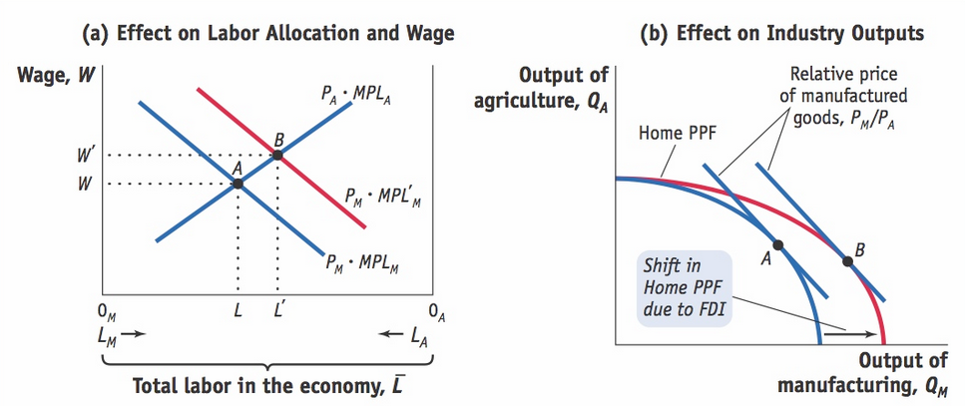
Figure 1: The Specific-Factors Model

Looking at the impact on industry outputs, the shift in labor causes a decrease in the output of the agricultural sector and an increased output in the manufacturing sector which is represented by the outward shift of the production possibility frontier (PPF). This outward shift in the PPF causes the point at which the country produces to shift from point “A” to point “B,” as shown in Figure 1 (Feenstra & Taylor, 2014). While these conclusions are promising toward elevating income levels and increasing output, these results only hold in the short-run. Moreover, many critiques exist regarding the use of the specific-factors model, most of which pertain to the oversimplifications made in the aforementioned assumptions.
Shifting to the long-run impact of FDI, the Heckscher-Ohlin model is employed to offer insight. Similar to the specific-factors model, the Heckscher-Ohlin model (H-O model) makes the following assumptions: (1) capital and labor are able to move freely between industries; (2) there are only two industries and two factors of production (labor and capital); and (3) one industry is capital-intensive and the other is labor-intensive. The model begins in the autarky equilibrium at point “A” in the left panel of Figure 2. The top and bottom axes measure the total amount labor (L) and the left and right axes measure the total capital (K) in the economy. However, the inflow of capital causes the total amount of capital in the economy to increase which requires an upward elongation of the graph; however, the capital to labor (K/L) ratios remain the same through the reallocation capital and labor (Feenstra & Taylor, 2014).
Figure 2: The Heckscher-Ohlin Model
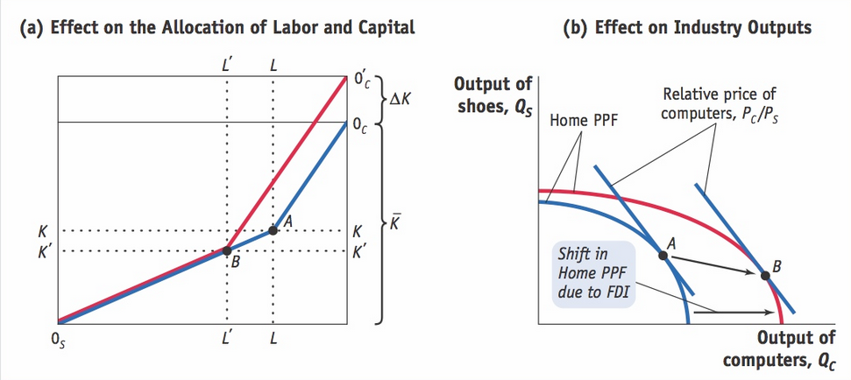
The right panel in Figure 2 depicts the outwards shift of the production possibility frontier as a result of the increased capital; however, as the capital to labor ratio does not change neither do the factor prices. Therefore, the marginal product of labor (MPL) does not change and neither does the wage or rental on capital (Feenstra & Taylor, 2014).
Model Results
Utilizing these three models discussed in the previous section, this paper will seek to demonstrate and analyze: (1) the results and evidence from each model as it pertains to each research question posed in the introduction; (2) the summary of results and evidence more broadly applicable to the overarching hypothesis; and (3) the comparison of these results to previous findings in the germane literature surveyed for this paper. Looking first at the IPRS-FDI nexus, the results are drawn from Branstetter and Saggi’s North-South model. The second research question which examines the link between FDI and economic development will draw results from both the specific-factors model (in the short-run) and the Heckscher-Ohlin model (in the long run).
Branstetter and Saggi’s North-South model is extremely insightful in providing a comprehensive, logical theoretical model to answer the first research question – will the strengthening of intellectual property rights lead to an increase in the influx of foreign direct investment for a developing country. This model concluded that by strengthening IPRS in the South, the following results would occur: (1) the cost of imitation by Southern imitators would increase making it less attractive to imitate goods and services; (2) this poses less of a risk for imitation, and therefore, the incentive for FDI by the Northern multinationals would increase; (3) these aforementioned effects would engender an increased demand for labor in the South and would lead to an increase in real wages; and (4) concurrently, the rate of innovation in the North would increase as more labor employed by the Northern firms and Northern multinationals can focus on innovation as opposed to production. Therefore, these results align with the statement that strengthening IPRS incontrovertibly leads to increased FDI in developing countries. In addition, the model asserts that the Northern multinational corporations experience gains through engaging in FDI in countries with strengthened IPRS.
In answering the second question – does an increase in foreign direct investment engender economic development – a discussion regarding conciliating the results of both the trade models employed is necessary to assert one holistic response. The specific-factors model which analyzed the effects of FDI on the economy in the short-run found that an increase in the flow of capital leads to an increase in the amount of labor allocated to the capital-intensive sector, which in turn leads to an increase in the equilibrium wage and an increase in the output of the economy. Referring to the earlier indicators defined as demonstrating economic development, both the increased real wage and increased output are indicative of economic growth occurring as a result of FDI. Shifting to the long-run, the Heckscher-Ohlin model concludes that – since capital and labor are free to be reallocated between sectors in the long-run – the inflow of increased capital leads to an extension of the economy’s capital; however, the capital to labor ratio remains the same and with such the wage rate and factors prices remain unchanged as well. However, the H-O model does definitively argue that the output is increased as the graph in Figure 2 demonstrates an outward shift of the PPF. Therefore, in the most basic sense the H-O model agrees that FDI engenders economic growth, which this analysis will consider an aspect and indicator of economic development. In comparing and compiling both of these results, the models demonstrate at least some level of economic development resulting from the increased level of FDI occurring in the economy.
Looking at the broad hypothesis for this research paper – that strengthening IPRS has a positive relationship with economic development via the means of international trade – the answers from both of the research questions definitively assert that this hypothesis is true – at least in a theoretical sense. While an empirical model would be more convincing in arguing that this relationship is bolstered by real-world occurrences and trade patterns, this analysis decided against the utilization of an empirical model due to the difficulties in measuring many of the variables utilized in this analysis. However, the hypothesis for this paper is, nonetheless, bolstered by strong theoretical evidence, and this evidence aligns with many other seminal scholars in the fields of international trade and economic development. Incongruent with most existing literature, this analysis facilitated a discussion on and attempted to prove both research questions in looking at the relationship IPRS and economic development – as opposed to much literature which takes one of these research questions as an assumption. In doing so, this analysis makes a more convincing, more evidence-based argument that strengthening IPRS leads to an increase in FDI, which in turn engenders economic development.
Country-Specific Data and Analysis
This analysis will utilize Kenya as a case study to test the validity of the three models previously employed in the Models and Methodology section. In selecting one specific country, this analysis hopes to bolster these theoretical models by way of providing a quasi-empirical analysis. Kenya will serve as the country of focus due to its recent adoption of intellectual property rights legislation into their constitutional framework in 2010. As mentioned throughout the literature on intellectual property rights, defining one specific measure to encapsulate the complex concept of intellectual property rights has yet to be accomplished; therefore, finding data on intellectual property rights proved to be onerous and challenging. Ergo, in lieu of specific quantitative measure of intellectual property rights, this analysis will utilize major changes in intellectual property rights legislation – namely the most recent change to the Kenyan constitution – and focus on the resulting changes in foreign direct investment. Further, the analysis will examine how changes in foreign direct investment effect the level of economic growth as measured by Gross Domestic Product per capita at Purchasing Power Parity (GDP per capita at PPP).
Looking at the changes made to the Kenyan Constitutional Framework with the adoption of a section protecting intellectual property rights, one must be aware that IPRS-protective legislation existed prior to its addition into the constitution. Rather, the addition of this legislation to the constitution is monumental as this is the first instance in which intellectual property rights legislation has been added at a national level to Kenya; therefore, this addition is the most authoritative step toward stronger intellectual property rights (Tuli, n.d.). Considering its inception in 2010, this official intellectual property legislation should – as per the theoretical model – affect the FDI inflow beginning as early as 2010 or 2011. Examining the FDI inflows as reported by the World Bank Group (depicted in Appendix 1) there has been a rapid, unprecedented increase in FDI inflows since 2011 making Kenya one of the largest FDI recipients in sub-Saharan Africa. While the increase in FDI as a result of stronger IPRS is congruent with the expectation of the theoretical model, other factors could hold explanatory power in elucidating this rapid change in FDI as well. For example, the increased FDI could be in part a result of increased investment by emerging economies – like China and India – in developing countries specifically in the sub-Sahara African region. Therefore, while these results indicate that the strengthening of IPRS engendered some level of growth in FDI inflows, the exact degree to which the new legislation is responsible for the increase is ambiguous. This specific limitation could be delimited and mitigated through the development of a more precise measure of intellectual property rights which could be utilized to develop further empirical analyses of this subject.
Transitioning to the second research question, a basic bivariate correlation analysis between the Foreign Direct Investment Inflows and the GDP per capita at PPP from 1990 to 2015 was completed. The Pearson Correlation Coefficient resulting from this bivariate correlation analysis was .709 with a two-tailed statistical significance of .000 making the correlation highly statistically significant. Further testing the relationship by employing an ordinary least square (OLS) linear regression analysis with the GDP per capita at PPP (the dependent variable) as a function of the FDI inflows (the independent variable) the OLS linear regression analysis indicated that the regression results were highly statistically significant and produced the equation: y = 1.046915017·10⁻⁶ x + 1826.394933. While the model utilized here to test the relationship between FDI and economic growth is overly simplified – suggesting that only FDI is an explanatory variable of GDP per capita at PPP – it nonetheless demonstrates the statistically significant relationship between FDI and economic growth in Kenya.
Considering these results and their limitations due to the ambiguous nature of the outcomes, the analysis of Kenya as a case study does not conflict with the findings of the theoretical model. Rather, the findings from this country specific data analysis are congruent with the outcomes of the theoretical models; however, the ambiguity resulting from the lack of data on the strength of the intellectual property rights as well as from the simplicity of the model makes it impossible to indicate exactly to what degree the strengthening of IPRS engenders economic growth and economic development.
Discussion and Conclusion
Utilizing international trade – and FDI more specifically – as the intermediary means in which to cause economic growth and development, the aforementioned models and results support this paper’s hypothesis that there exists a positive relationship between strengthening IPRS, increasing FDI, and economic growth and development. Utilizing a North-South trade model, the specific-factors model, and the Heckscher-Ohlin model, the comprehensive results from all three maintain that strengthening IPRS increases the attractiveness to Northern states leading to increased vertical FDI which in turn leads to increased wage growth and output in the short-run and steady wages with increased output in the long-run. Analyzing the results cultivated by testing these models with country-specific data from Kenya, the empirical results indicate the models are valid; however, there exists a large amount of ambiguity in the empirical results due to the dynamic-nature of economic growth and development, as well as the challenges with successfully measuring intellectual property rights. Additionally, much of the country-specific analysis has indicated that the increased FDI engenders economic growth, not economic development. Economic development, much like intellectual property rights, is difficult to measure and the lack of specificity in the data increases the difficulty in asserting that the economy has developed, rather than just grown. The confirmation of economic development is derived exclusively from the results of the two international trade models which demonstrate a movement of labor from the agricultural industries to the manufacturing industries. This analysis maintains that this movement from agriculture to manufacturing is economic development as manufacturing provides individuals with a steadier income than agriculture – not to diminish the importance nor the potential for income security from agriculture. Moreover, the models indicate an increase in total output and an increase in technology, both of which this analysis considers indicators of economic development.
This relationship between intellectual property rights, foreign direct investment, and economic growth and development, while complex, is beneficial to all developing economies and their policy-makers, as employing IPRS as a means to engender economic growth and development has been significantly demonstrated as a good policy for nation states with extremely weak IPRS. Future research could, and should, focus on a more rigid empirical model; however, first, some universal formula should be created as to avoid the inconsistencies present in the FDI data. Moreover, indicators on IPRS should be created and used to measure IPRS beyond simply the amount of patent rights present within a nation state. In fixing these data related limitations, an empirically rooted model could better demonstrate this theoretically proven relationship.

Bibliography
Curtis, J. (2012). Intellectual property rights and international trade: An overview. (Centre for International Governance Innovation Working Paper No. 3). Waterloo, Canada: CIGI.
Feenstra, R. & Taylor, A. (2014). International trade 3e. New York: Worth Publishers.
Goans, J. (2003). Intellectual property and developing countries: An overview. (Briefing Paper: December 2003). Washington, D.C.: United States Agency for International Development (USAID).
Hassan, E., Yaqub, O., & Diepeveen, S. Intellectual property and developing countries: A review of literature. Santa Monica, CA: RAND Corporation prepared for the UK Intellectual Property Office and the UK Department for International Development.
Maskus, K. (2000). Intellectual property rights and economic development. (Beyond the Treaties: A Symposium on Compliance with International Intellectual Property Law Series). Cleveland, OH: Fredrick K. Cox International Law Center at Case Western Reserve University.
Maxwell, A. & Riker, D. (2014). The economic implications of strengthening intellectual property rights in developing countries. Journal of International Commerce and Economics,6(5), 1-9. Retrieved from https://www.usitc.gov/publications/332/journals/vol_vi_article5.pdf
Primo Braga, C. & Fink, C. (1998). The relationship between intellectual property rights and foreign direct investment. Duke Journal of Comparative & International Law, 9(1), 163-187. Retrieved from http://scholarship.law.duke.edu/cgi/viewcontent.cgi?article=1244&context=djcil
Tewari, P. (2013). Prospects and views on to strengthening intellectual property rights (IPRS) in developing countries, with special reference to foreign direct investment (FDI). International Journal of Scientific & Engineering Research, 4(6), 1932-1950. Retrieved from http://www.ijser.org/researchpaper%5CPROSPECTS-AND-VIEWS-ON-TO-STRENGTHENING-INTELLECTUAL-PROPERTY-RIGHTS-IPRS-IN-DEVELOPING-COUNTRIES.pdf
TRIPS: What are IPRS. (n.d.). Retrieved from https://www.wto.org/english/tratop_e/trips_e/intel1_e.htm
Tuli, A. (n.d.). The constitutional framework for the protection of intellectual property rights in Kenya. Retrieved from https://www.academia.edu/9007001/The_Constitutional_Framework_For_The_Protection_of_Intellectual_Property_Rights_in_Kenya
World Bank. (2016). World Development Indicators. [Data file]. Available from World Bank website: http://databank.worldbank.org/data/reports.aspx?source=world-development-indicators
Appendix 1: FDI Inflows in Kenya
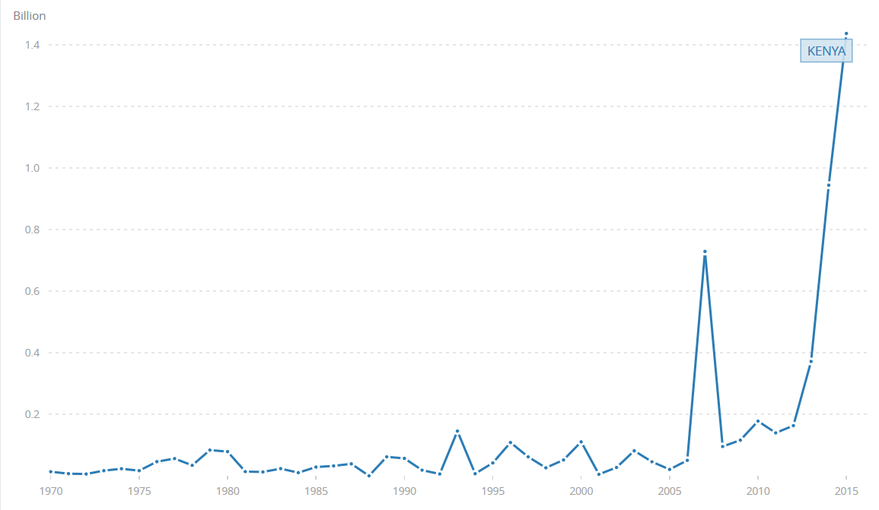
Retrieved from the World Bank: http://data.worldbank.org/indicator/BX.KLT.DINV.CD.WD?locations=KE

